**Installation Instructions for the ECMAPI RESTful Service**

**Prepared by Willy Heineman**

**December 7, 2014**

# Introduction

The ECMAPI Service is a RESTful Service that provides HTTP access to the OpenLAB ECMAPI. It is designed as a V3.5 .NET executable to be installed on IIS version 7 or higher.

# Pre-requisites

The following are required before installation:

1. The ECMAPI Service package, EcmRestService.zip.
2. A server where OpenLab 3.4x is installed. Admin privileges on the server.
3. IIS 7 or better should be installed on the server.
4. The IIS Web Deployment Tool should be installed to IIS. The installer for this tool can be found here: <http://www.iis.net/downloads/microsoft/web-deploy>

The “Internet Information Services (IIS) Manager” tools will be used throughout this document. The following screenshot shows the panels of interest:

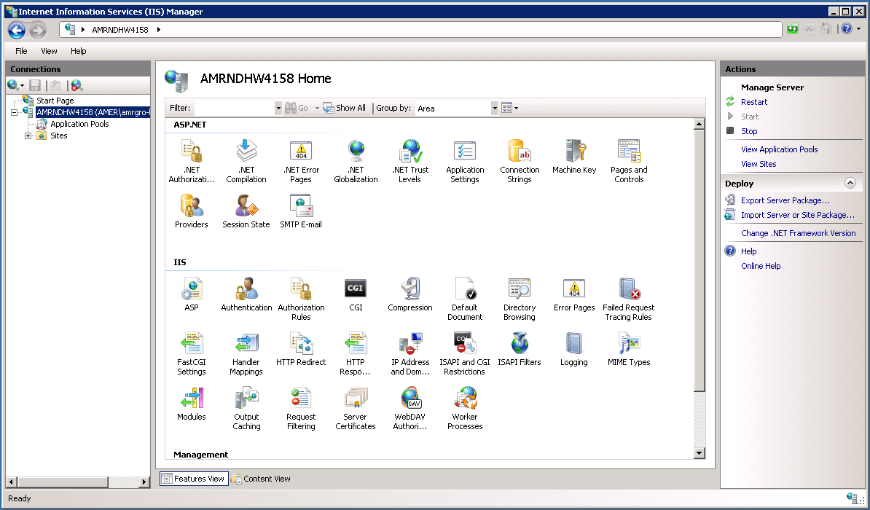

# Determining if the ECMAPI Service is already installed

If the ECMAPI Service is already installed it will need to be uninstalled before installing. Instructions for uninstalling can be found in this document in the section titled “Uninstalling the ECMAPI Service”. To determine if the ECMAPI Service is already installed please execute the following steps:

1. Log on to the server.
2. Start the “Internet Information Services (IIS) Manager” software.
3. In the left hand panel, click on the “Sites” folder.
4. In the “Sites” folder, expand the “Default Web Site” node.
5. If the “EcmRestService” deployment is listed, then the ECMAPI Service is installed and will need to be removed before installing.

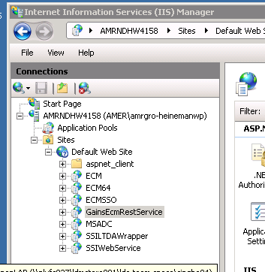

# Installing the ECMAPI Service

1. Log on to the server.
2. Start the “Internet Information Services (IIS) Manager” software.
3. If this is the first time the service is being installed, create the following directory “C:\Program Files (x86)\Pfizer\EcmRestService”.
4. Copy the EcmRestService.zip file to the directory “C:\Program Files (x86)\Pfizer\EcmRestService”.
5. Start the “Internet Information Services (IIS) Manager” software.
6. In the left hand panel, click on the “Sites” folder.
7. Right click on the “Default Web Site” node and select the “Deploy/Import Application” sub menu item.
8. Browse to the “C:\Program Files (x86)\Pfizer\EcmRestService” and selec the EcmRestService.zip file.
9. Click the “Next” button.
10. Click the “Next” button.
11. In the text field shown, modify the “EcmRestService_deploy” text to “EcmRestService”.
12. Click the “Next” button.
13. Click the “Finish” button.
14. Click on the node named “Application Pools” in the left hand panel.
15. If the Application Pool “APIPool” is not present, click on the “Add Application Pool” link in the “Actions” right hand panel, otherwise skip to step 18.
16. In the “Add Application Pool” Dialog enter “ECMAPIPool” in the “Name” text field.
17. Click the “Ok” button.
18. Click on the newly created “ECMAPIPool” entry, and the “Advanced Settings” in the right hand panel.
19. In the “Advanced Settings” dialog box, change the “Enable 32-bit Applications” setting from “False” to “True” and click the “Ok” button.
20. Click on the “EcmRestService” node in the left hand panel and click on the “Basic Settings” link in the right hand panel.
21. In the “Edit Application” dialog box click the “Select” button for the “Application Pool”.
22. Select the “ECMAPIPool” from the “Application Pool” dialog box and click on the “Ok” button.
23. Click the “Ok” button of the “Edit Application” dialog box.

At the completion of step 21, the service is installed.

# Verifying the installation of the ECMAPI Service

Open a browser and enter into the locator field the following URL:

<http://YourServer/EcmRestService/EcmApi.svc/version>

If the service is functional you should see this:

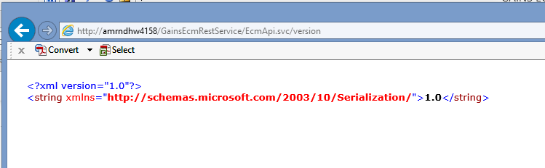

If the service was not installed properly or is not functional, you will see something like this:

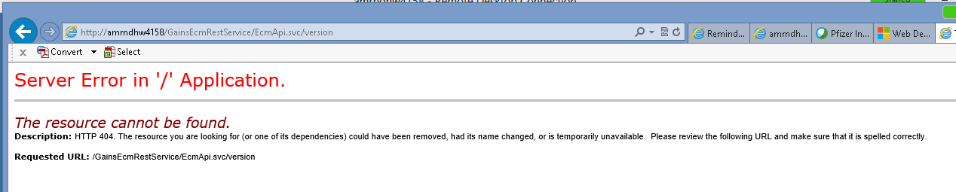

# Uninstalling the ECMAPI Service

To uninstall the ECMAPI Service from a server, do the following:

1. Log on to the server.
2. Start the “Internet Information Services (IIS) Manager” software
3. In the left hand panel, click on the “Sites” folder.
4. In the “Sites” folder, expand the “Default Web Site” node.
5. Right click on the “EcmRestService” node and select the “Deploy/Delete Application and Content” sub menu item.
6. Select the “Ok” button on the dialog box shown.